**Deep Learning**

* There are total 5 Parts of Deep Learning :-

ANN

CNN

RNN

Autoencoders and GAN

Object Detection and image Segmentation

1. **ANN**

* ANN stands for artificial neural network.

**🧠 What is a Perceptron?**

* The **perceptron** is the **simplest type of artificial neural network**, and it was one of the first algorithms proposed for supervised learning of binary classifiers.
* It was invented in 1958 by **Frank Rosenblatt** and is the **building block** for more complex neural networks used in deep learning today.

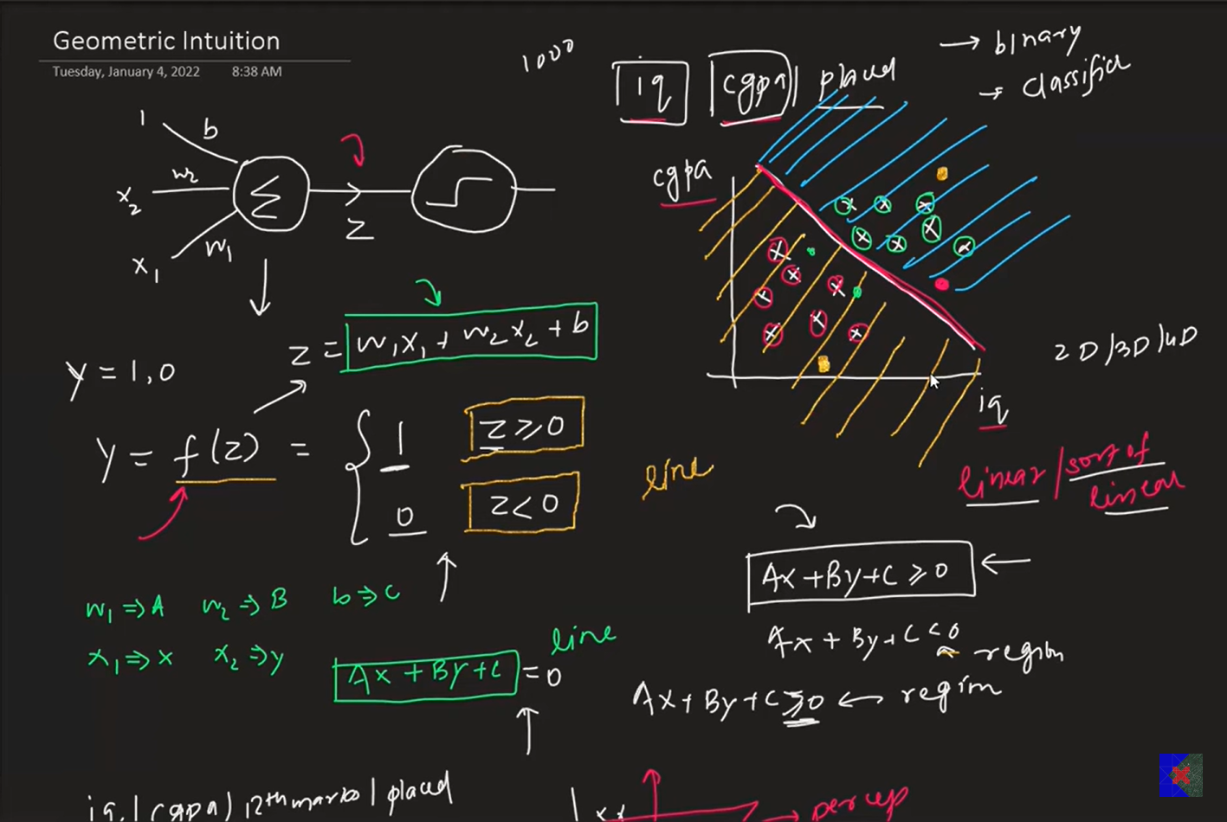

**Step-by-step Flow:**

1. **Inputs:**  
   Multiple numerical values (features), e.g., [x₁, x₂, x₃].
2. **Weights:**  
   Each input is multiplied by a weight [w₁, w₂, w₃].
3. **Weighted Sum:**  
   The perceptron computes:

Z = w1x1 + w2x2 + w3x3 + b

- where b is the bias.

1. **Activation Function:**  
   The result z is passed to an activation function (usually a **step function** in basic perceptron):

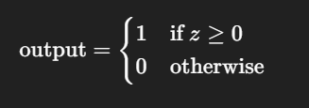

1. **Output:**  
   A single binary value (0 or 1) indicating the predicted class.

**❌ Problems with the Perceptron**

**1. Cannot Solve Non-Linearly Separable Problems**

* The **biggest limitation** is that the perceptron can only solve **linearly separable** problems (like AND, OR).
* It **fails on XOR** and similar problems where a straight line cannot separate the classes.

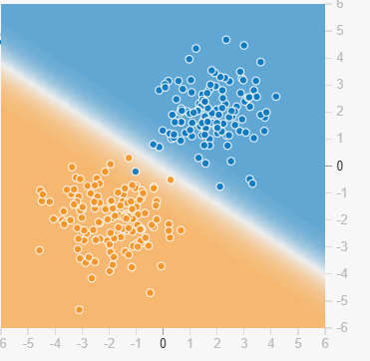

It will perform well with this type of linear data.

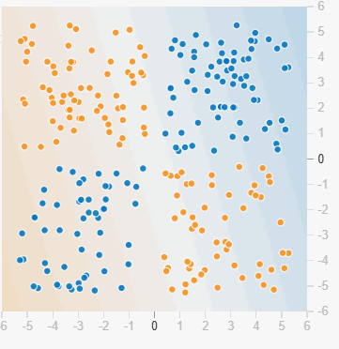

It will not perform good with this type of non-linear data.

* **Because of these issues we need to use MLP (Multi-Layer Perceptron).**

**MLP (Multi-Layer Perceptron)**

* In multi-layer perceptron we have to use multiple perceptron. the difference between single perceptron and a multi-layer perceptron is in single perceptron input comes from data and in MLP input comes from multiple perceptron and that input goes into another perceptron and output of that perceptron goes inside sigmoid function and that will give output as a probability.
* **MLP Notation**

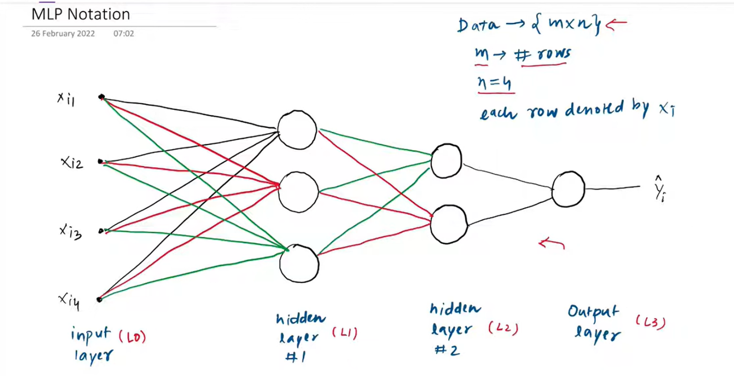

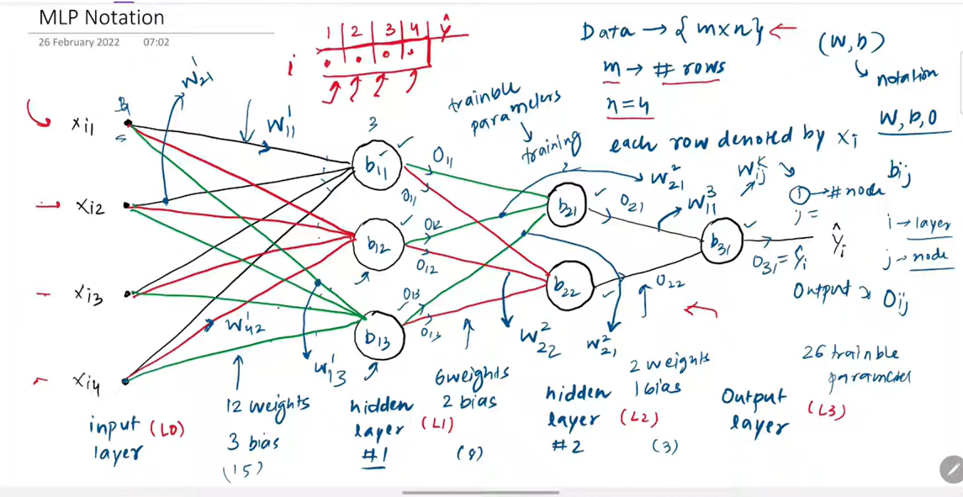

* In this neural network there are total 26 trainable parameters.
* There are 2 hidden layer first with 3 nodes and second with 2 nodes.
* There are input layer and output layer are present.
* In first layer there are total 12 weights (4 input * 3 nodes of 1’st hidden layer) and 3 bias are

(b11, b12, b13).

* In second hidden layer there are total 6 weights and 2 bias are (b21, b22).
* And there is one bias in output layer called b31 and 2 weight.

**🔁 What is Forward Propagation?**

* **Forward Propagation** is the **first step in training a neural network**, where the input data passes through the network **layer by layer** to produce the final output.
* 📌 It’s called *“forward”* because the data flows **from input → hidden layers → output layer**.

* This is how we can make our own Neural Network :

1. Churn-prediction

<https://www.kaggle.com/code/riyankvaghasiya/churn-prediction-ann-sigmoid>

1. Number classification

<https://colab.research.google.com/drive/1iOLqqMe_qHoGZr_yr-esCRTQpQm4-hSh?usp=sharing>

1. Graduate Admission

<https://www.kaggle.com/code/riyankvaghasiya/graduate-admission-ann>

**🧠 What is a Loss Function?**

* A **loss function** is a mathematical function used to quantify the **difference between the predicted output** of a model and the **true target value**. The goal of training is to **minimize this loss**.
* Loss function is a method of evaluating how well your algorithm is modeling your dataset.
* If loss function is high that means our algorithm is working poor and if our loss function is small that means our algorithm is working great.

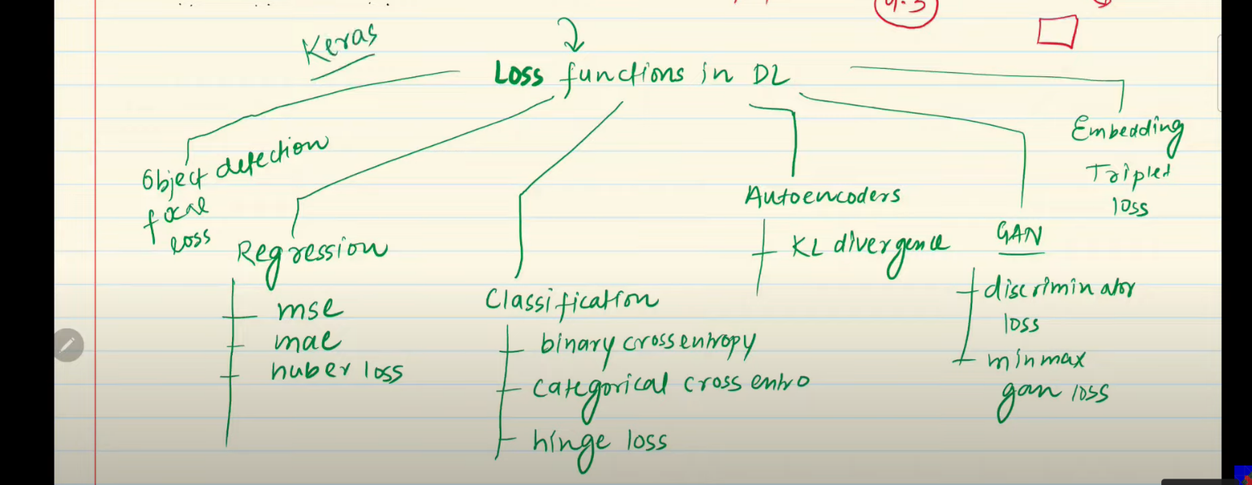

**📌 1. Mean Squared Error (MSE)**

* It is use for Regression.

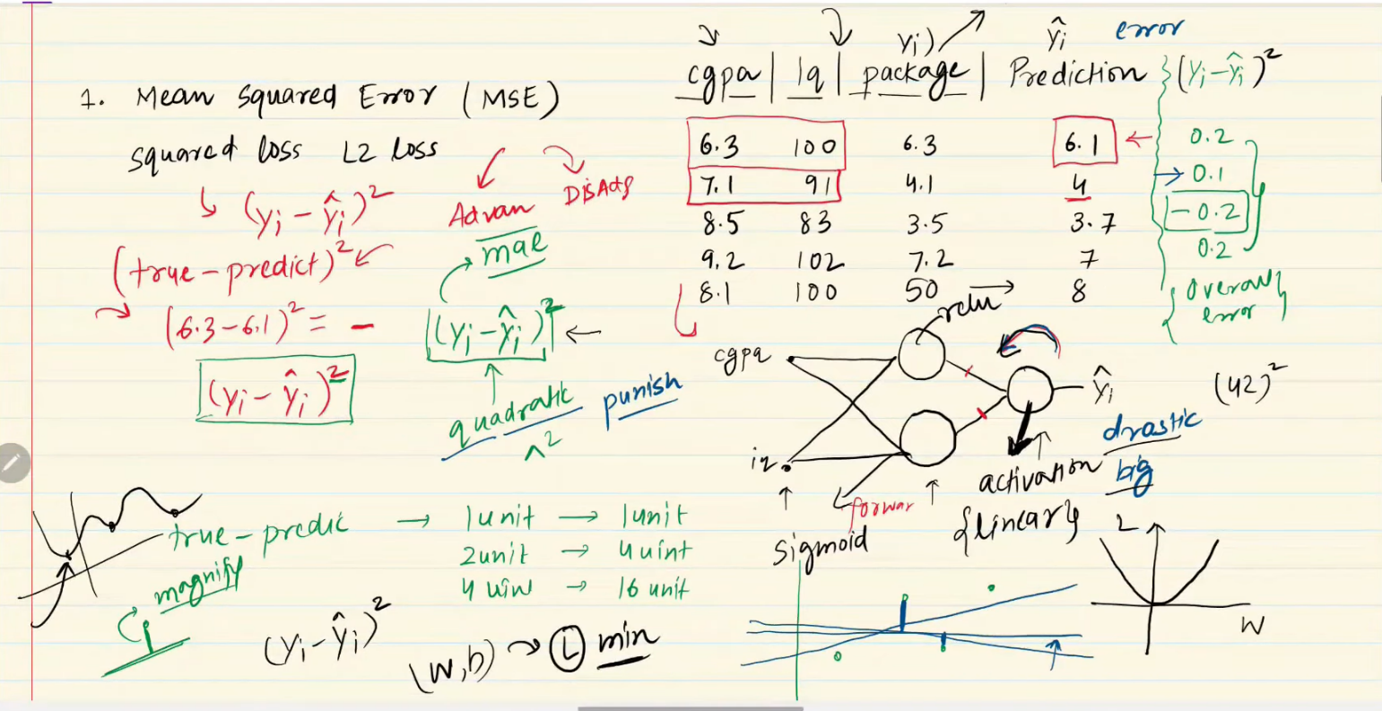

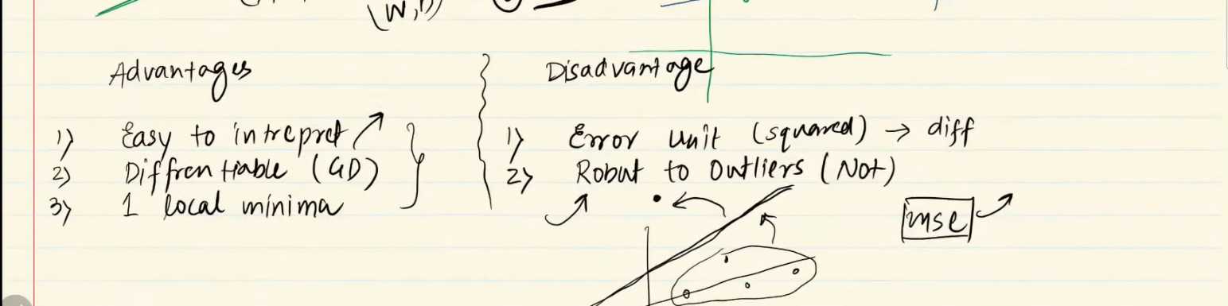

**NOTE: If our data contains outliers then use mean absolute error and if it has not any outliers then use mean squared error.**

**📌 2. Mean Absolute Error (MAE)**

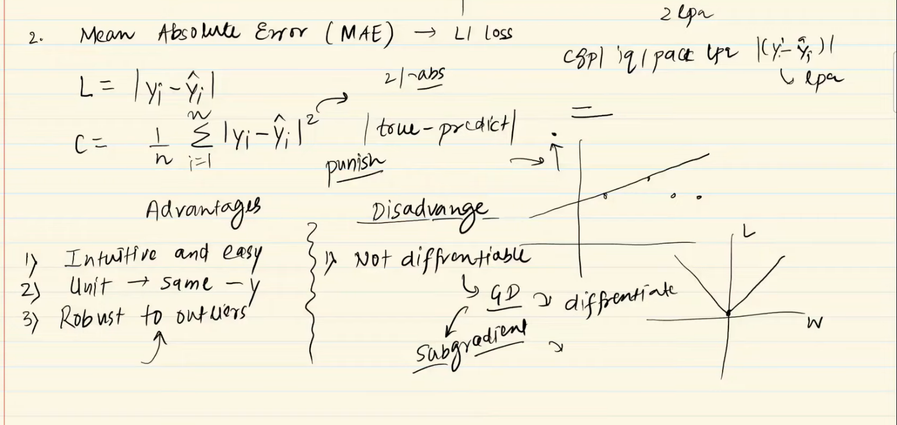

**📌 3. Huber Loss (Smooth L1 Loss)**

* Huber loss is used when we have data with many numbers of outliers.
* This is a combination of MSE and MAE.

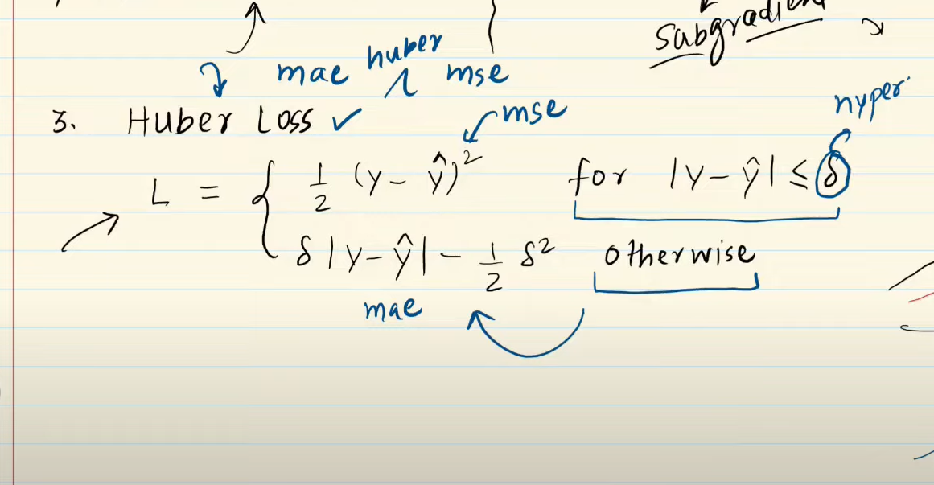

**📌 4. Binary cross Entropy**

* It is use in classification problem where result is true or false.
* If we use this loss function, then we must use the sigmoid activation function in output layer.

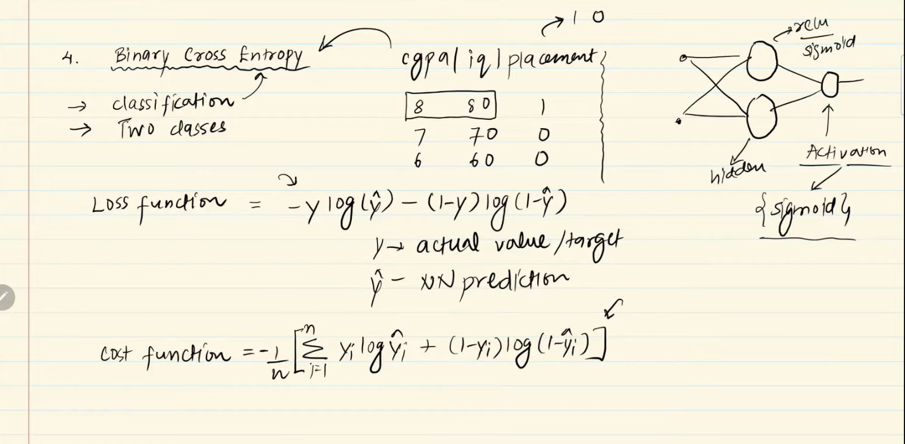

**📌 5. Categorical cross Entropy**

* It is use in classification problem.
* We use this function when data is multi-class. (ex. Output is yes or no or maybe in classification)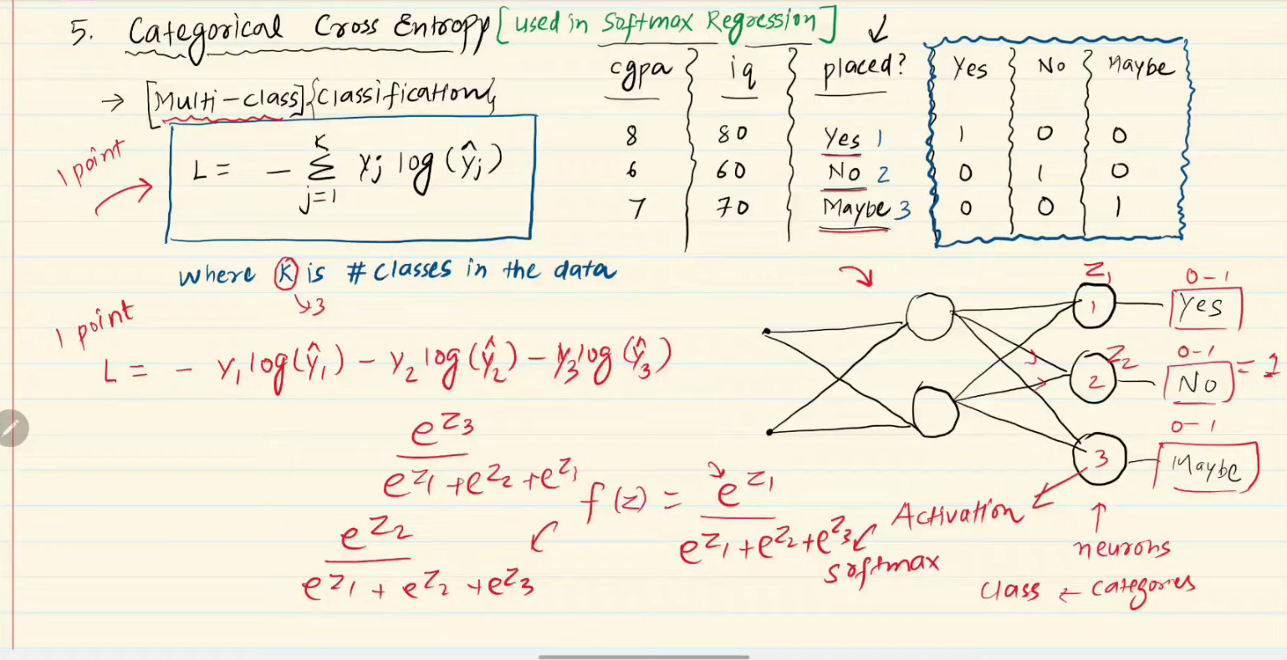

**🔁 What is Backpropagation?**

* **Backpropagation** (short for *“backward propagation of errors”*) is the algorithm used to **train neural networks** by:

1. Calculating how much each **weight** in the network contributes to the total **loss (error)**.
2. Updating the weights using **gradient descent** to reduce the error.

* It’s the **engine** that powers learning in modern deep learning models.

**🎯 Goal of Backpropagation**

* To **minimize the loss function** by adjusting the weights and biases in the network using **gradient descent**.

**🧠 How It Works: Conceptual Overview**

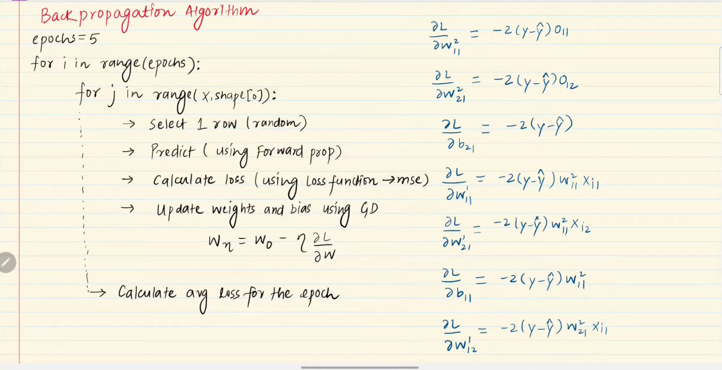

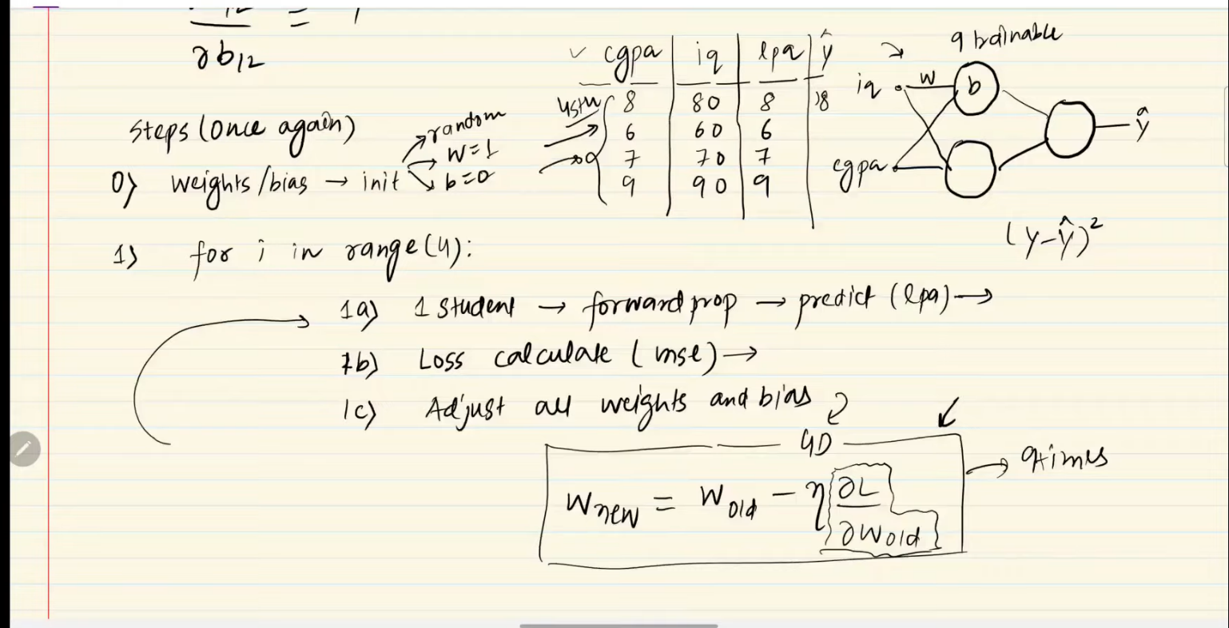

* Loss function is a function of all trainable parameters means value of loss function depend on all the trainable parameters (all the weights + all the bias).
* We have to make loss function minimum by changing the value of weights and bias.

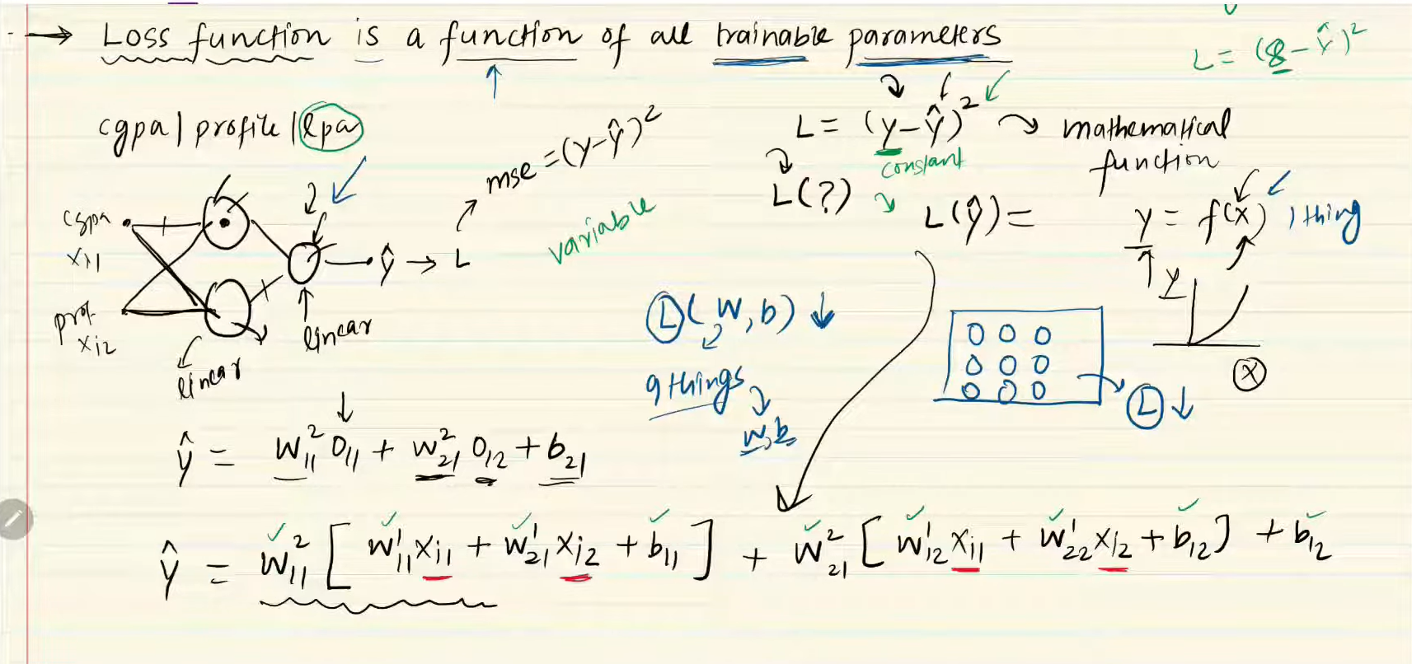

* In above neural network we can see that there is total 9 trainable parameters that means value of loss function will depend on all of these 9 parameters.

🤖 What is MLP Memoization?

**1. Using Memoization to Optimize MLP Computations**

In this context, **Memoization** can refer to **caching intermediate results** during:

* **Forward propagation**
* **Backward propagation**
* **Gradient calculations**
* Simply Memoization Is a technique in which it stores derivatives or math calculation of node to use it in next further calculation.
* Main goal of this technique is to save time and reduce the complexity of backward propagation.

**Backward Propagation = Chain rule (differentiation) + Memoization**

**📉 What Is the Vanishing Gradient Problem?**

* During backpropagation, gradients (i.e., partial derivatives of the loss with respect to weights) are used to update the network weights.  
  In deep networks, **gradients become smaller and smaller** as they are propagated back to the earlier layers.
* Eventually, **early layers receive extremely small gradients**—so small that they **stop learning altogether**. This is known as the **vanishing gradient problem**.

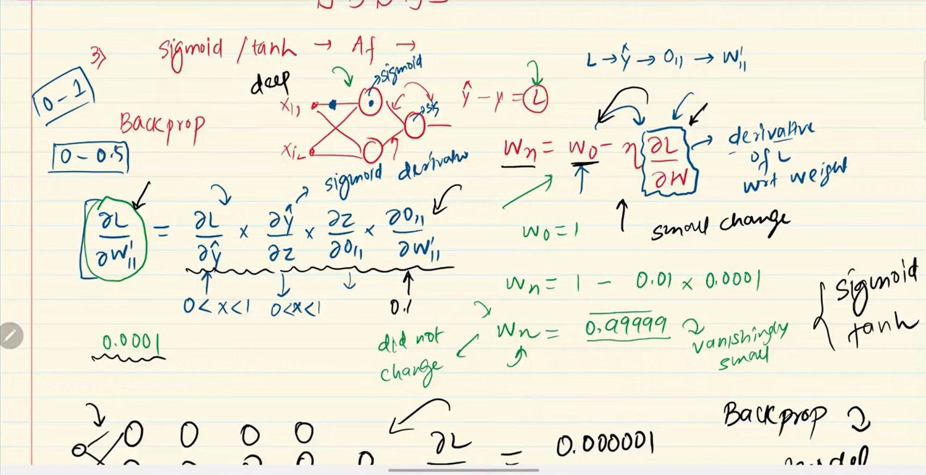

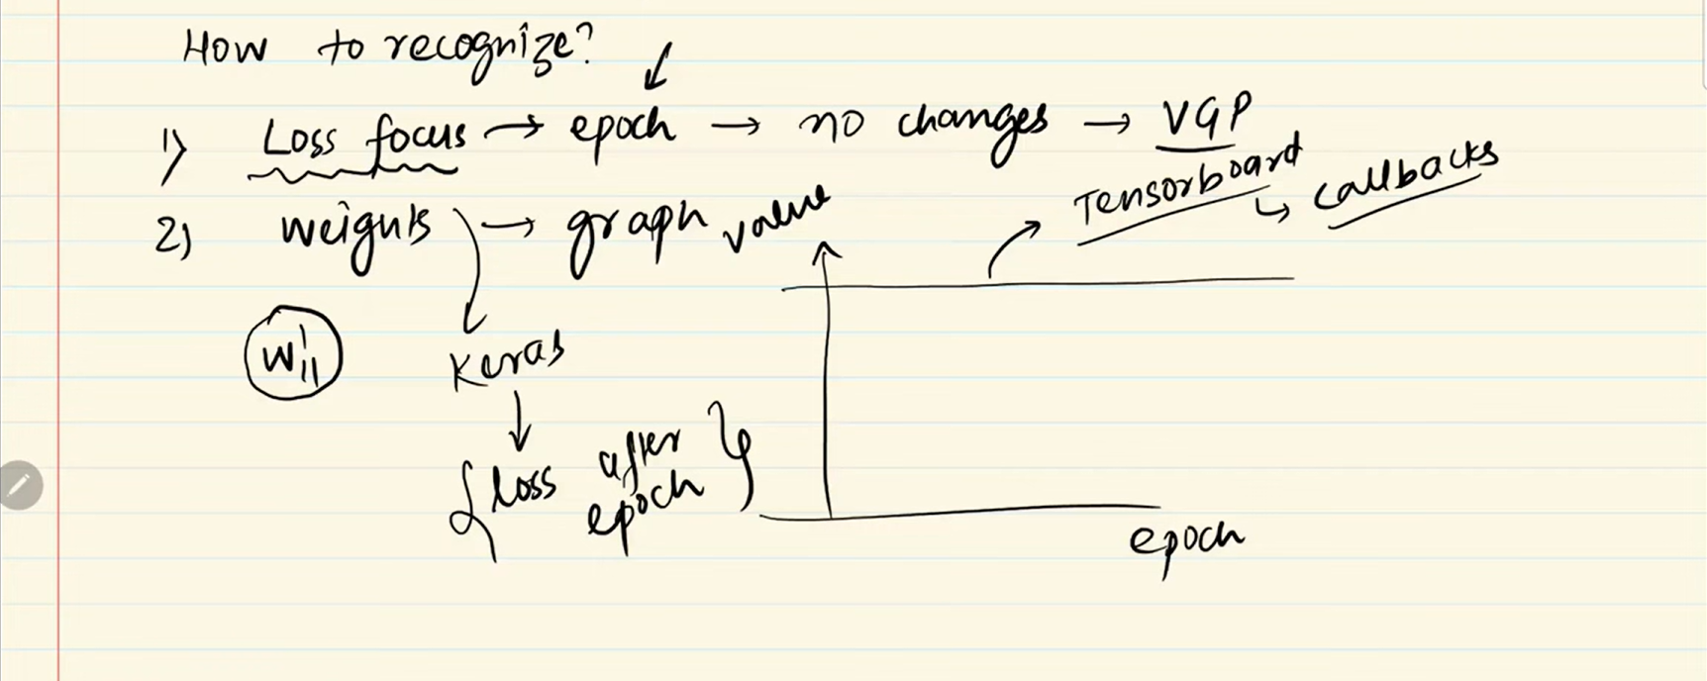

🛠️ How to Solve Vanishing Gradient Problem?

* 1. By reducing complexity of model (by reducing hidden layer).
  2. Using different activation function (use Relu).
  3. By proper weight initialization (use Xavier/Glorot).
  4. Use batch normalization.
  5. Using a residual network.

📈 How to improve a Neural Network.

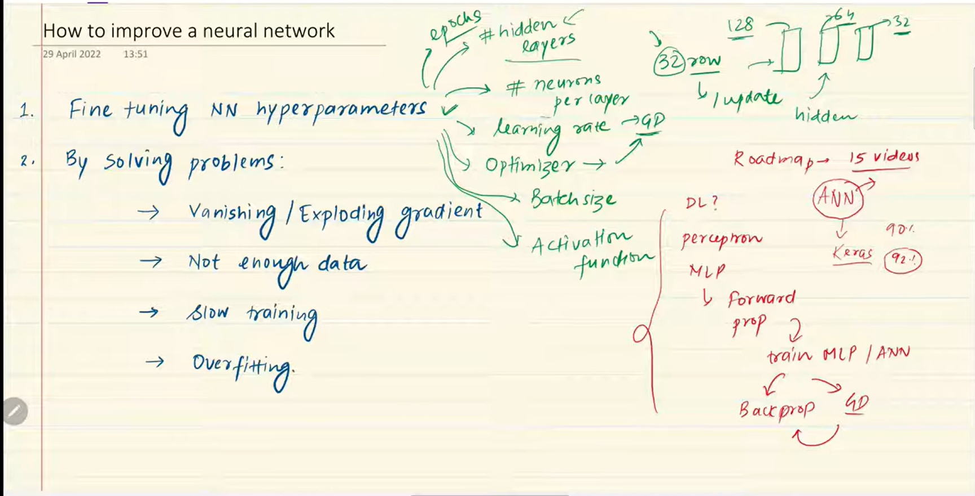

⭐Fine tuning hyperparameters.

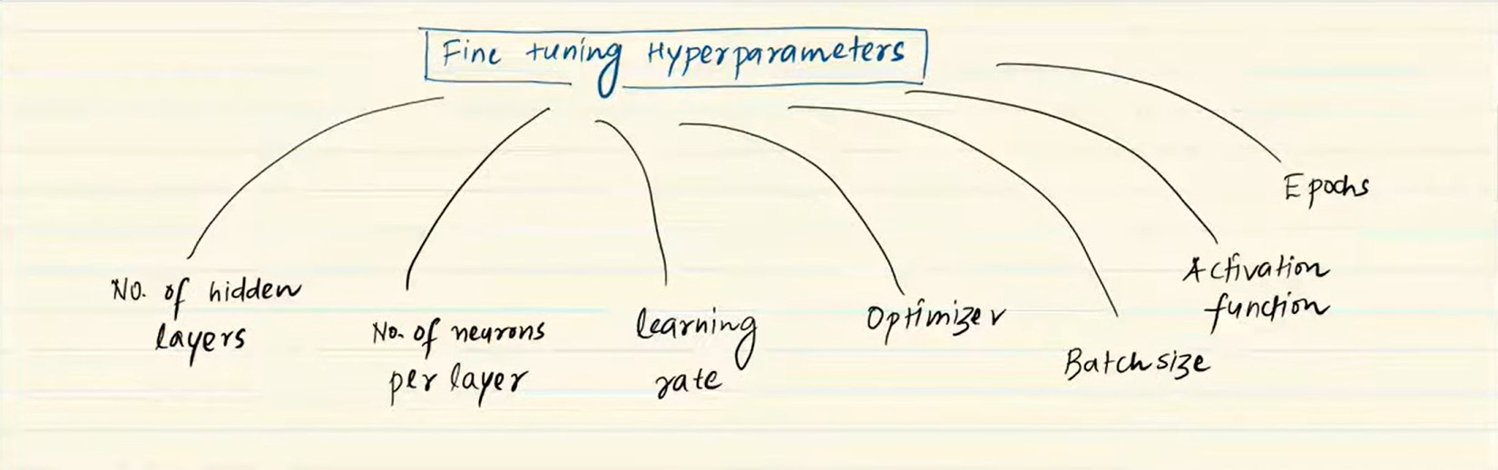

* In this technique we have to decide values of our hyperparameters.

1. Number of Hidden layers:

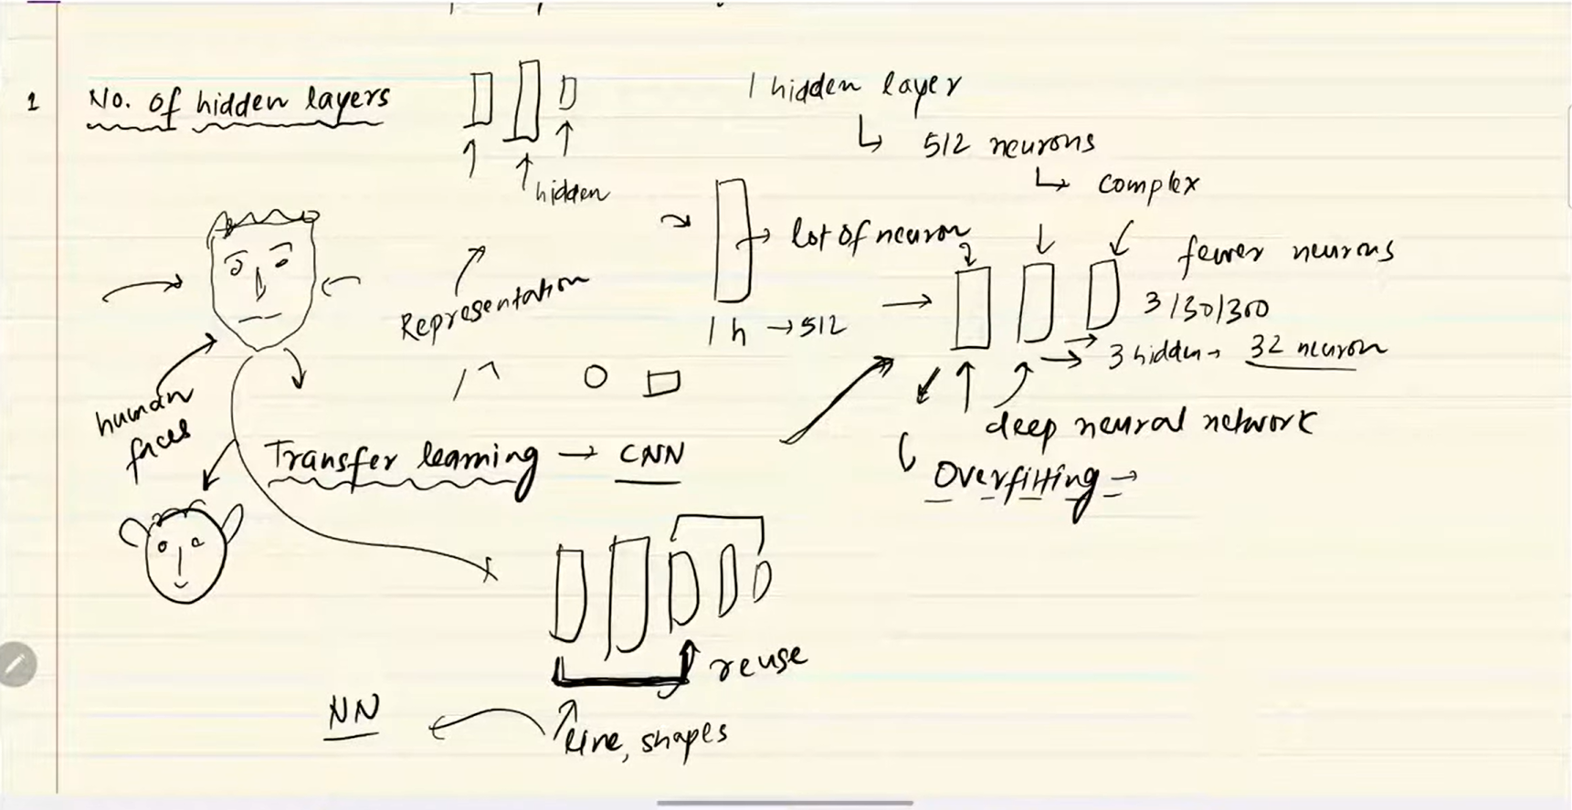

* Always take multiple number of hidden layers, instead of taking one hidden layer with so many nodes take multiple number of hidden layers with lesser number of nodes.
* This structure can handle any level of complex data.
* Stop adding hidden layer when overfitting occurs.

1. Number of neurons per layer:

* Always take sufficient number of nodes.

1. Batch size:

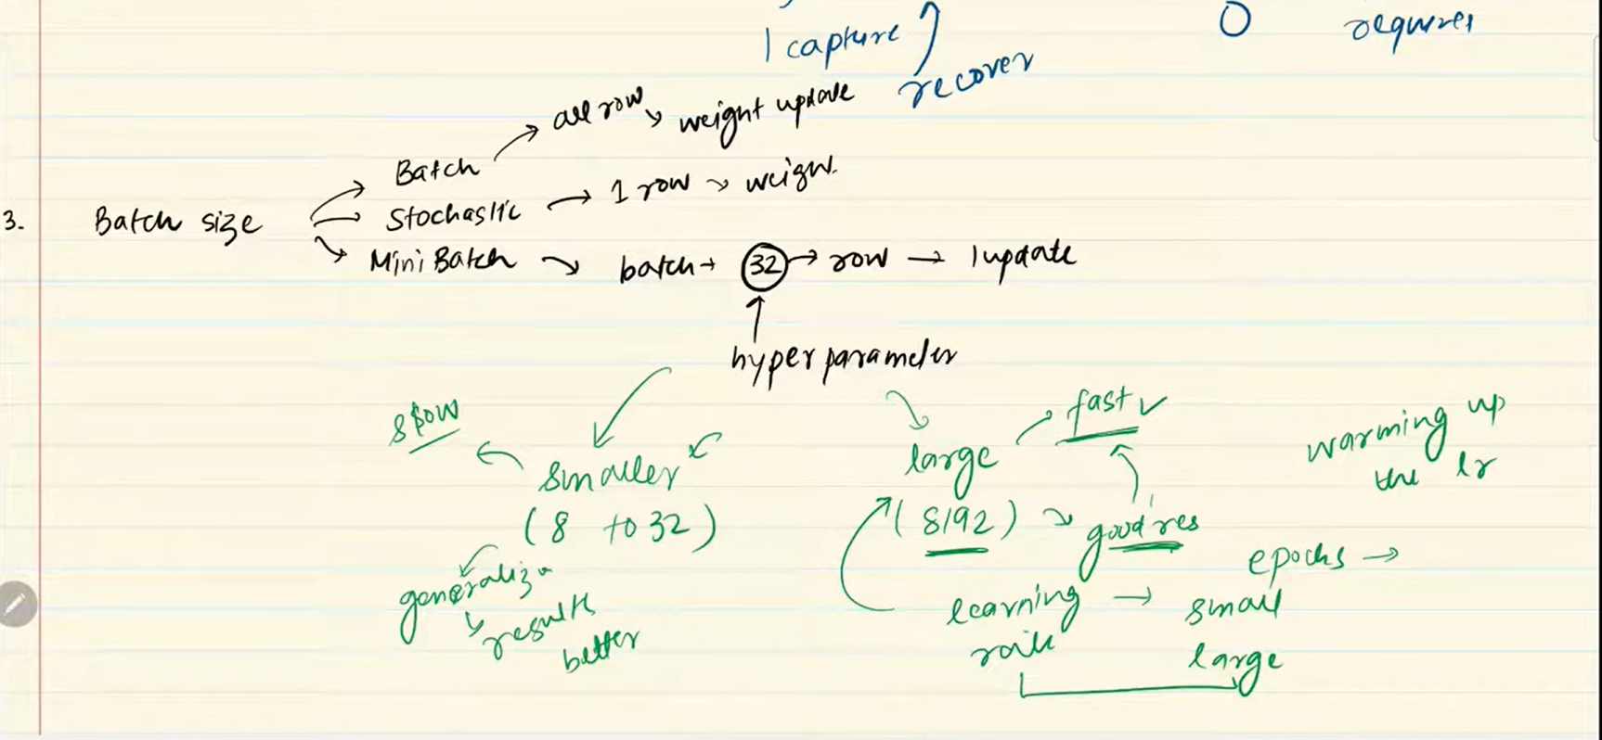

* We should use technique in which we use larger batch size and if it not works then we should go for smaller batch size.

⭐Problems with Neural Networks:

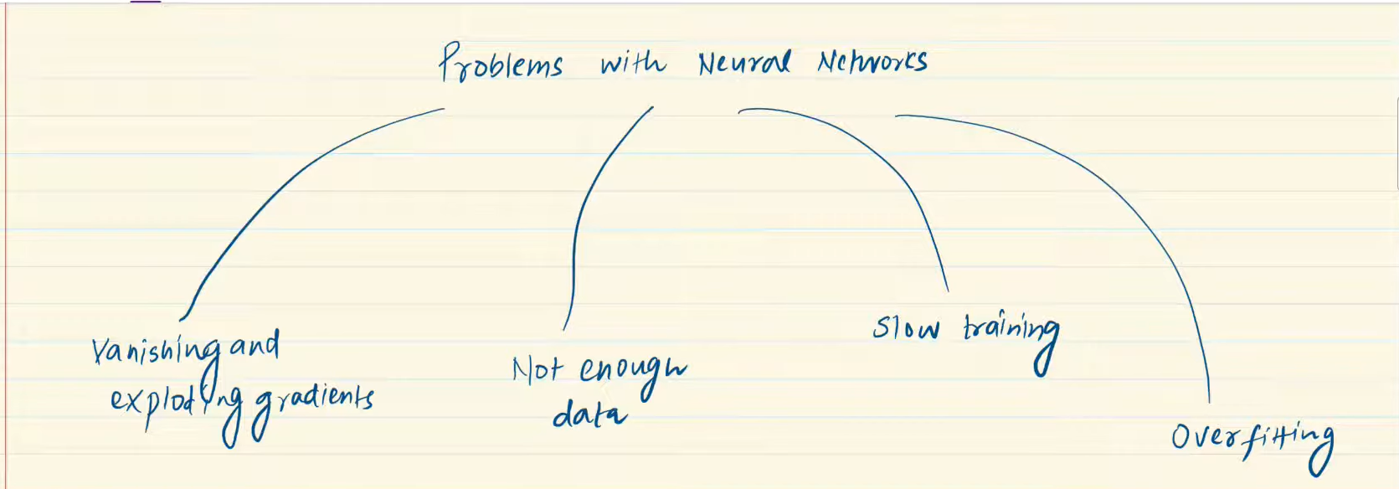

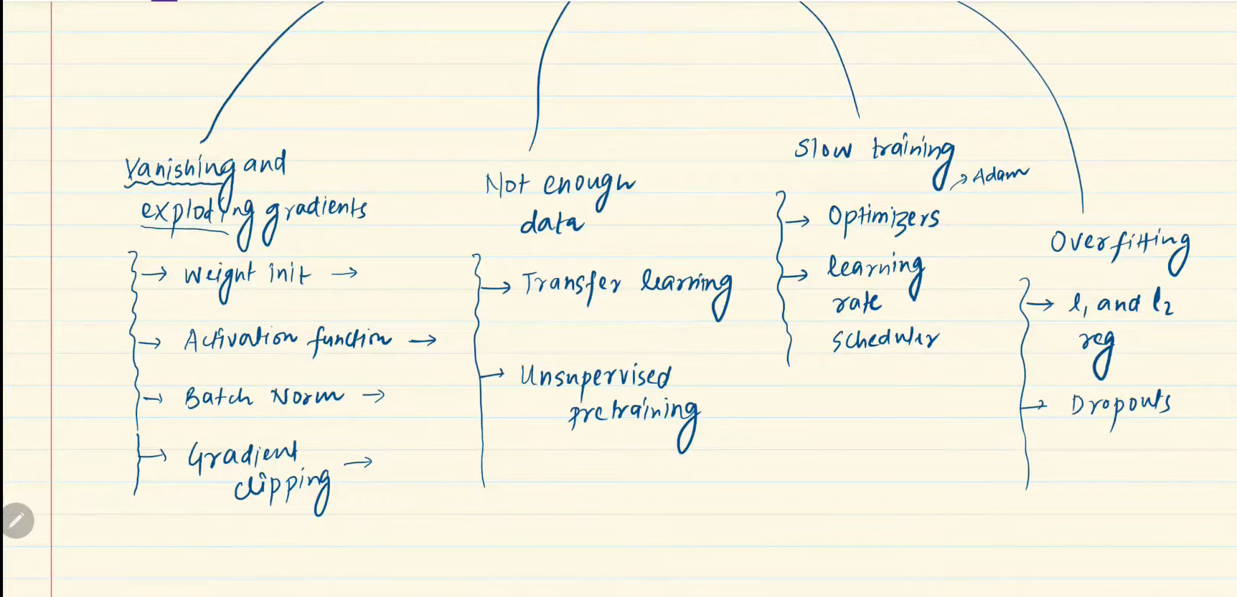

* If we solve above problems then we can achieve a good neural network.

**🛑 What is Early Stopping in Deep Learning?**

* **Early Stopping** is a **regularization technique** used to **prevent overfitting** in deep learning models by **halting training** when the model's performance on a **validation dataset starts to degrade**.
* It is used to measure number of epochs in algorithm.
* It prevents overfitting and saves training time.
* Sample code: -

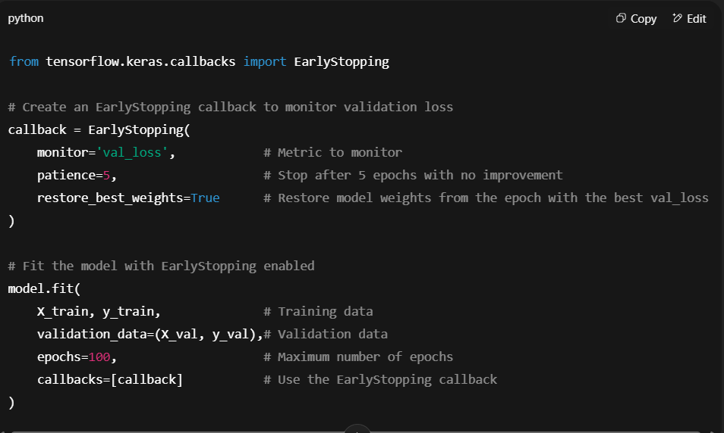

**🧠 What is Dropout in Deep Learning?**

* **Dropout** is a regularization technique used in deep learning to **prevent overfitting** by randomly “dropping out” (i.e., setting to zero) a fraction of the neurons during training. This forces the model to not rely too heavily on any one neuron and encourages it to learn more robust, distributed representations.

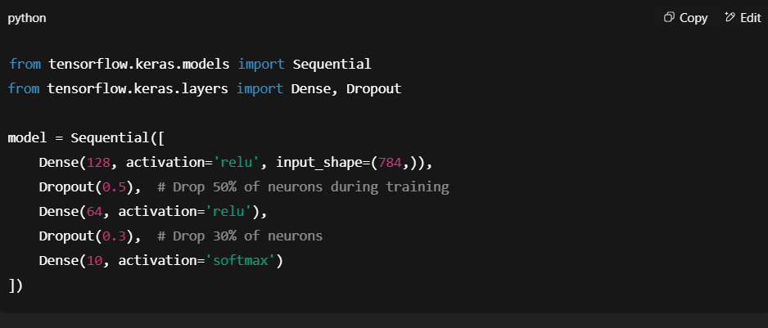

* Value of P (dropout(p)) is depend on overfitting and underfitting if model overfit data, then increase the value of p and if model underfit data then decrease the value of p.

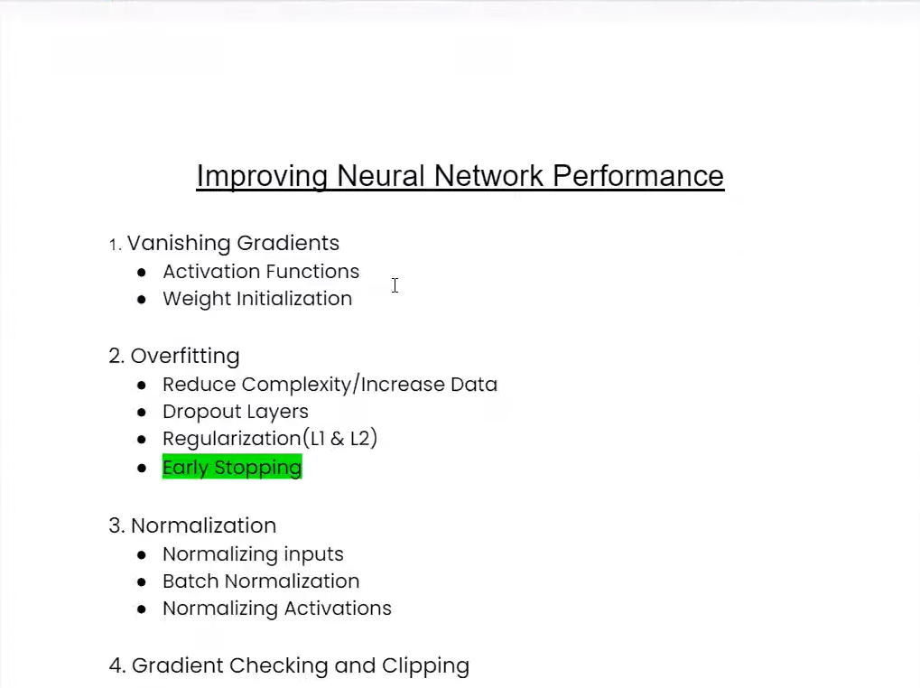

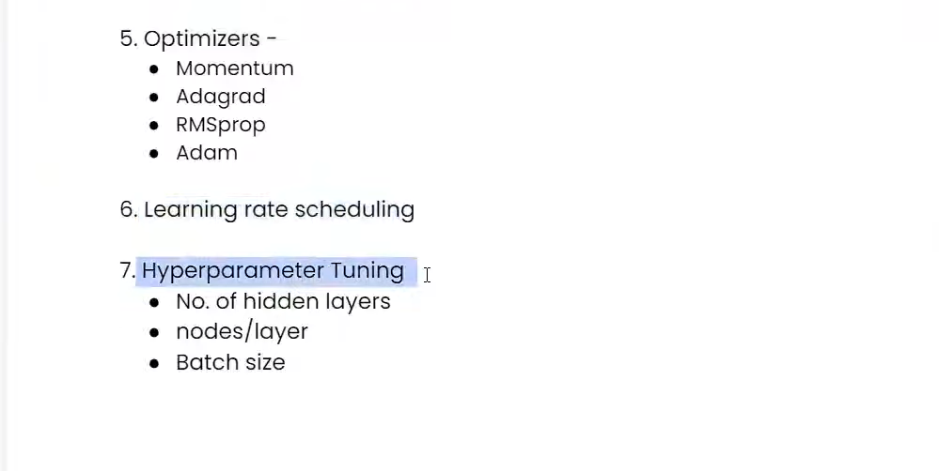

What are Activation functions?

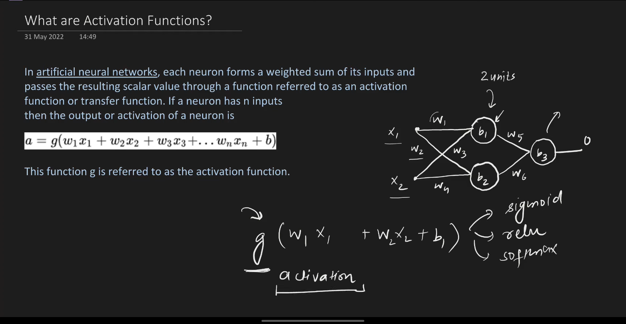

1. Sigmoid Activation function.

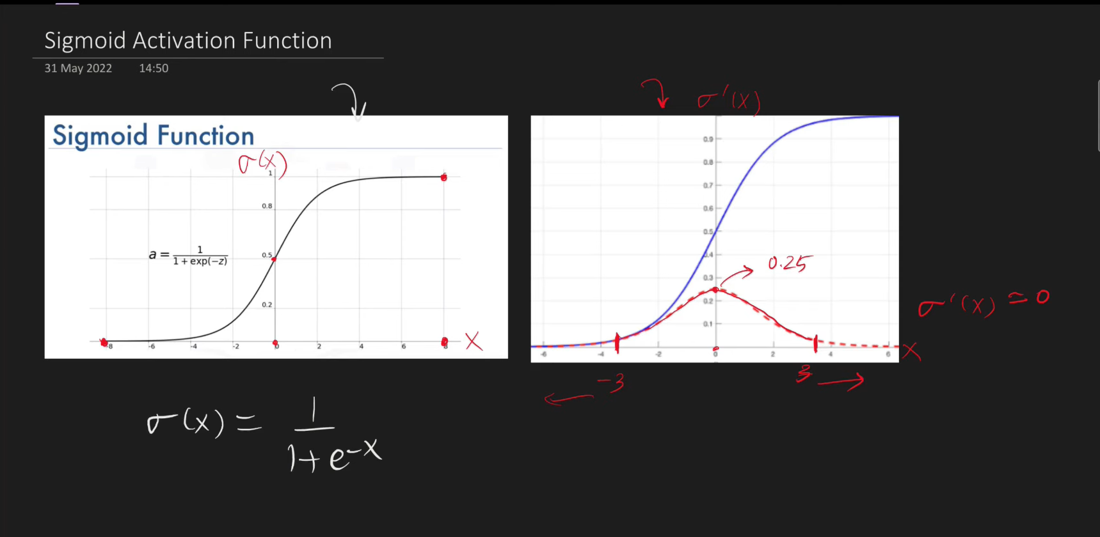

* Output of sigmoid range between 0 and 1. So we can use it like probability.
* We can use sigmoid function in output layer when we work on binary classification problem.
* It is a non-linear function we can use in non-linear data.
* It is a differentiable.

1. **Tanh (Hyperbolic Tangent) Activation Function**



* Output is range between -1 to 1.
* **Zero-centered** — helps convergence faster than sigmoid.
* Strong gradients in the central region.

1. **ReLU (Rectified Linear Unit)**

Formula:

ReLU(x)=max(0,x)

* Output range between [0,∞)
* **Does not saturate** in the positive region → avoids vanishing gradient
* **Computationally efficient**
* Sparse activation → activates only some neurons.
* **Dying ReLU Problem**: neurons can die during training (output remains 0 for all inputs).
* Not zero-centered.

⭐ What is Weight initialization?

* Weight initialization is a **critical step** in training deep neural networks. The way you initialize the weights can significantly affect:
* How fast your model trains (convergence speed)
* Whether the model learns at all (avoiding exploding/vanishing gradients)
* The final model performance

**📘 Why Is Weight Initialization Important?**

When training a neural network:

* Each layer passes its output to the next layer
* If the weights are too **small**, gradients **vanish**
* If the weights are too **large**, gradients **explode**

So, initialization techniques aim to **preserve the variance of activations and gradients** across layers.

⭐ Things not to do in weight initialization

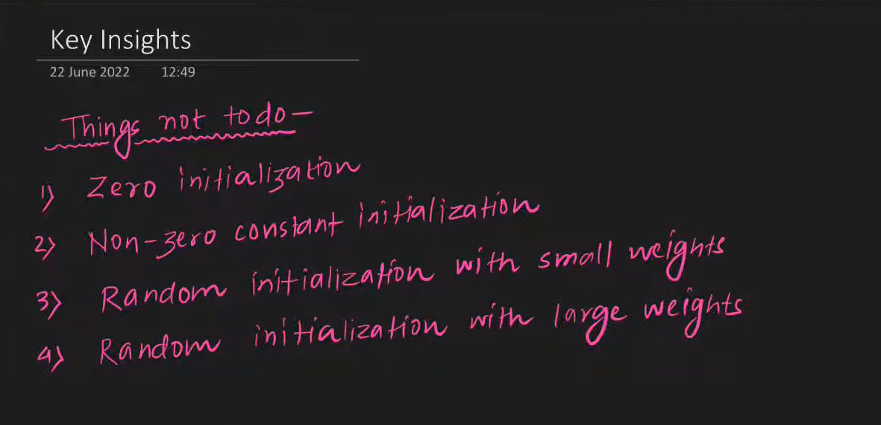

1. **Xavier/Glorot Initialization (for tanh, sigmoid)**

* Designed to keep the **variance of activations constant** across layers.
* We can use Xavier in tanh but we cannot use in relu.

1. **He Initialization (Kaiming Initialization) (for ReLU or variants)**

* This technique is use in relu.